Term Website Planning Document Peer Review
Site Purpose
Being in such a beautiful place like Cozumel you want to spend the most time adventuring, this is why this webpage will provide all the information needed for a user to select a scooter that best fits its need in traveling.
Logo

Domain
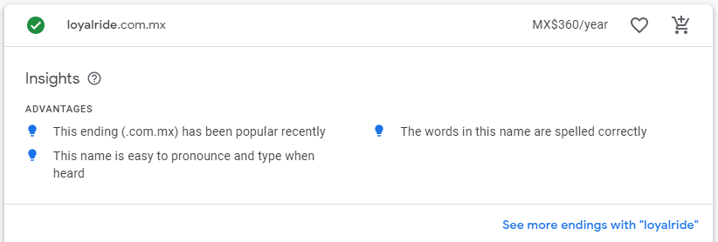
loyalride.com.mx
Target Audience
Personas
Jake
- 22 years old
- Male
- Jake has just finished his bachelor’s degree in Computer Science and came to Cozumel with two other friends to have some fun after the stress of collage. He wants to have the most fun as possible, he has some savings he is willing to spend all in this trip. He saw an photo on Instagram of this company and decides to google it for more information.
Melissa
- 33 years old
- Female
- Melissa is on a vacation trip with her family, consisting of her husband and two kids of 7 and 6 years old, both male. Everybody in the family enjoys having fun, but Melissa is also conscious of the risks this involves. She wants to visit as many places as possible but having a vehicle that is safe, comfortable and that all the family can fit. The family is not worried to much about the money, they have a company that is making good profit.
Site Map

Color Scheme
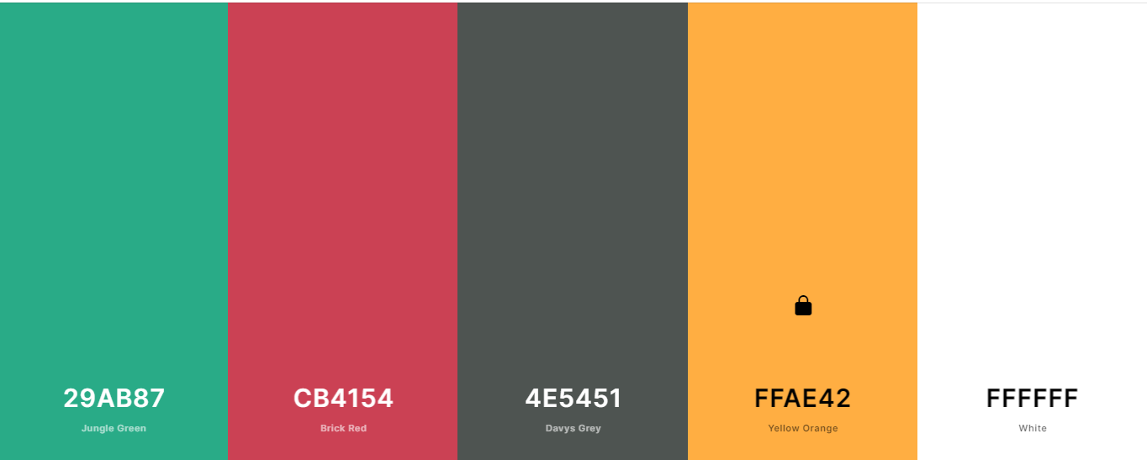
Typography
Headings: Rubik Bold 700

Paragraphs: Noto Sans Regular 400

Wireframe Sketches
Coming soon…

